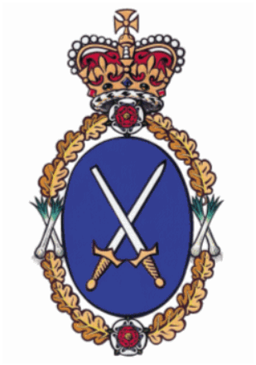

High Sheriff
of
Clwyd
Community Awards 2027

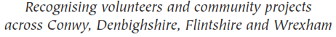

Guidance Notes and
Nomination Form

Supported by

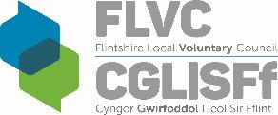
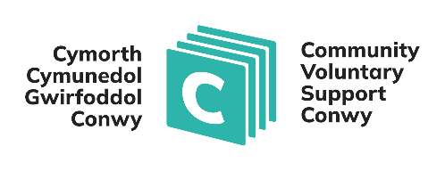

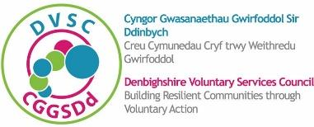

FOREWORD

The role of High Sheriff has a history stretching back over a thousand years. The role is a Crown appointment, and historically its purpose was to represent the Monarch in matters of law and order within their county. There are fifty-five High Sheriffs in the United Kingdom, with eight of these being in Wales. Over the years the role has evolved and adapted to keep it relevant in today’s society, and supporting and promoting the voluntary and community sector has become an important part of the role. High Sheriffs are appointed annually by the Monarch, and in Clwyd the role broadly covers the local authority areas of Conwy, Denbighshire, Flintshire and Wrexham.

I have witnessed for many years how volunteers are active in the heart of every community across Clwyd. Volunteers consider themselves ordinary but many are doing extraordinary things, and in my year of office I have tried to spotlight just some of the organisations and people who are enriching our communities with their dedication and passion. In a world of gadgets and technology the importance of community and communication must not be forgotten.

Being High Sheriff is a privilege and an honour, and the High Sheriff Awards provides an opportunity to recognise, celebrate and applaud the hard work and dedication of some of the outstanding people across Conwy, Denbighshire, Flintshire and Wrexham, Denbighshire.

I have been humbled and inspired by the people I have met over recent months, and I encourage you all to make your nominations, putting forward the names of remarkable individuals and groups from across a wide range of voluntary and community activities.

Choosing the winners will not be an easy task and I am very much looking forward to meeting the eventual award winners at the awards ceremony in March 2027.

David B Jones OBE DL
High Sheriff of Clwyd 2026/27

Stephanie Catherall
High Sheriff of Clwyd 2019/20

INTRODUCTION

The High Sheriff of Clwyd’s Awards were launched in 2013 to recognise individuals or voluntary/ community organisations or groups (with charitable aims) that have made an outstanding contribution to their respective communities.

Awards are made annually to individuals and to voluntary/community organisations or groups (with charitable aims) operating within each of the County Voluntary Councils (CVCs), namely Conwy, Denbighshire, Flintshire and Wrexham, that form the preserved County of Clwyd

AWARDS CEREMONY

The winners will be presented with their awards at an event to be held in early March 2027, and further details will follow in due course.

NOMINATION PROCESS AND CONDITIONS

- Subject to the following, anyone may make a nomination for their area and/or Clwyd, including people who benefit from the individual or voluntary/community group’s activities.
- You can only make one nomination.
- Individuals cannot be nominated by a partner or family member or nominate themselves.
- An individual nominee must reside in one of the four CVC areas and be over 18 years of age.
- The nominee (whether an individual or an organisation/group) must not be contacted or made aware that they are being nominated for an award.
- Personal details provided on the nomination form may be passed to partner organisations and to the media for publicity purposes. If you do not wish for any information to be shared in this way or if you do not wish media organisations to contact the nominee or nominator, please let the appropriate CVC know as soon as possible.
- A Judging Panel, chaired by the High Sheriff of Clwyd, will assess the nominations and decide who will receive the awards. The Panel’s decision is final, and they reserve the right not to make an award.
- Nomination forms and Guidance notes can be downloaded from the appropriate CVC website or by post.
- The closing date for the submission of completed and signed nominations to
office@dvsc.co.uk is 5pm on Sunday 6th December 2026.

(If you require any further information, please
contact the appropriate County Voluntary Council – DETAILS BELOW)

COUNTY VOLUNTARY COUNCILS
Wrexham | Conwy | Denbighshire | Flintshire
High Sheriff Award  Dawn Roberts-McCabe  Chief Officer  AVOW  Tŷ Avow  21 Egerton Street  Wrexham  LL11 1ND | High Sheriff Award  Elgan Owen  Chief Officer  Community and Voluntary Support Conwy  7 Rhiw Road  Colwyn Bay  LL29 7TG | High Sheriff Award  Janine Downing  Chief Officer  Denbighshire Voluntary Services Council  Naylor Centre Well Street Ruthin  LL15 1AF | High Sheriff Award  Ann Woods  Chief Officer  Flintshire Local Voluntary  Council  Corlan Unit 3  Mold Business Park Wrexham Road Mold  CH7 1XP
info@avow.org  Tel. 01978 312556 | volunteering@cvsc.org.uk  Tel. 01492 523858 | office@dvsc.co.uk  Tel. 01824 702441 | info@flvc.org.uk  Tel. 01352 744000

Privacy Notice

The respective County Voluntary Council (CVC) that you submit the nomination form to, will be what is known as the ‘Controller’ of the personal data you provide. The information given will be entered and processed on computer by the relevant CVC; the forms will also be kept for 12 months after the closing date. The information will be used by the relevant CVC and the High Sheriffs Association for, inter alia, administration and publication purposes of the awards scheme and for the monitoring and promotion of the voluntary sector by the relevant CVC and High Sheriffs Association. Personal data is limited to contact names, address, telephone and other contact numbers, and e-mail; it may be considered as sensitive personal data where the organisation/project is involved with matters relating to race, ethnic origins, politics, religions or similar beliefs, physical, mental health or sexual life.

Part or all of the information you provide will be held securely on computer or in secure filing systems. All the personal data is processed by CVC staff in Wales. However, for the purposes of IT hosting and maintenance, this information is located on servers within the European Union.

The reason the CVC needs your data is to be able to administer the Award nominations. The CVC’s have collectively identified the reason for processing the data is a legitimate interest, and this is the lawful basis. This information will be used for the administration of the nominations and awards and for producing statistics. Copies of this information will be provided, when necessary, to individuals and organisations that the relevant CVC consults with when assessing nominations and awards.

Contact details will only be disclosed to third parties for the following purposes: to enable the CVC’s to process the nomination; to enable the High Sheriff to consider the nomination, to announce successful recipients, and to promote the High Sheriff of Clwyd Awards generally via press releases and other bona fide promotional activities including placement on the relevant CVC’s and High Sheriffs Association website and their other publications.

The respective CVC will forward a copy of this Privacy Notice to the nominee on the first communication with the nominee.

As a data subject you and the nominee may have the right at any time to request access to, rectification or erasure of your personal data; to restrict or object to certain kinds of processing of your personal data, including direct marketing; to the portability of your personal data and to complain to the UK’s data protection supervisory authority, the Information Commissioner’s Office about the processing of your personal data.

As a data subject, you are not obliged to share your personal data with the CVC. If you choose not to share your personal data with the CVCs, they may not be able to process your Award nomination.
THE HIGH SHERIFF OF CLWYD COMMUNITY AWARDS 2027

NOMINATION FORM

I/We wish to nominate the following individual/organisation for the High Sheriff of Clwyd
Community Awards 2027 for the area of * ______________________________
*Insert area (i.e., Flintshire, Denbighshire, Conwy or Wrexham in respect of nominations for individuals and organisations)

NOMINEE

Name of person/organisation nominated: (Mr/Mrs/Miss/Other) _________________________
Address: ___________________________________________________________________
__________________________________________________________________________
Telephone: _________________________________________________________________
Mobile: ____________________________________________________________________
Email: _____________________________________________________________________
NOMINEE

I/we wish to nominate the above named for the High Sheriff of Clwyd Community Awards for the reasons listed below.

I/we have read the eligibility criteria and agree to be bound by the conditions of entry. To the best of my/our knowledge all details are true and correct.

Name of nominator: (Mrs/Mrs/Miss/Other)__________________________________________________________
Organisation and Contact (if applicable): __________________________________________
Address: ___________________________________________________________________
__________________________________________________________________________
Telephone: _________________________________________________________________
Mobile: ____________________________________________________________________
Email: _____________________________________________________________________

Signature:____________________________ Date:____________________________
NOMINATOR
NOMINATOR

- How do you know the person/organisation nominated?

- Briefly describe the community/voluntary activities carried out by the nominee (please outline all relevant activities that you know the nominee participated in).
(maximum 250 words)

- How long has the nominee been carrying out the above listed activities?

- What is the relevance/benefit of the activities for the community?

- Please give the reasons why you consider the nominee should receive a High Sheriff’s Community Award.
(maximum 250 words)

Please return the completed signed nomination form to office@dvsc.co.uk or post to Denbighshire Voluntary Services Council, Naylor Centre, Well Street, Ruthin LL15 1AF
by 5pm on Sunday 6th December 2026.

